~ WEBSITE DETECTIVES ~
Name: __________________Class: __________
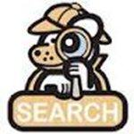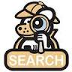
- Find 3 websites on the topic: ________________________________________
- Now you are going to be a website detective and decide if each website passes the 5 W’s test:

WEBSITE DETECTION CHART - 5W’s | Website 1 URL:  Name: | Website 2 URL:  Name: | Website 3 URL:  Name:
WHO is the author or sponsor of this site?
(e.g., name? degree? .edu?)
WHEN? Date?
Copyright year?
WHERE? Does this info. come from? Where can I find more info. from the website sponsor?
WHAT is the purpose of the site? P.I.E.
P = persuade you?
I = inform (teach)?
E = entertain you?

WHY?
Should I believe the info. from here?
Does this site pass the 5W’s test?

Should I trust / use this site?

