Cold Water Corals
(found in Canada and the Pacific West Coast)

- Prior to this lesson, share short, introductory videos on what is coral…
PART 1 – Introduction
Cold vs. Warm Water Corals
- 6,000 coral species globally
- 700 species are cold-water coral
- 45 cold water species found off Nova Scotia (Atlantic Canada) (DOF)
- 60 cold water species found off British Columbia waters

- Share video: Cold Water Corals of Canada – (17 min. video) Excellent resource!
http://science.gc.ca/site/science/en/educational-resources/marine-and-freshwater-sciences/oasis-deep
- Share Infographic– From Seattle Aquarium
https://www.seattleaquarium.org/sites/default/files/files/Coral%20Infograph2.pdf
Cold Water Corals and sponges – research from Dept. of Fisheries & Oceans
- “Many cold-water coral species grow slow but have a long life span
- Some individual coral species are nearly1,000 years old!
- Coral reefs can be many thousands of years old!
- In some coral species, each year’s growth shows up as distinct growth rings, like a tree.
- Coral growth rings provide scientists “a valuable window into the ocean climate of the past.”
Video notes: (on cold water corals) Students may want to use this info. for their research.
- Found in both shallow coastal and deep offshore waters, coral and sponges provide many ecosystem functions that are not yet fully understood.
- Corals are complex, many-celled organisms vs. sponges are very simple creatures with no tissues.
- Cold-water corals and sponges host distinctive communities of fish and other species while sponge reefs provide important nursery habitat for young rockfish.
- The Pacific North Coast Integrated Management Area (PNCIMA) is home to many of these, including the rare hexactinellid (glass) sponge reefs.
- Some of the coral colonies may be more than 100 years old
- some sponge reef communities may have developed over thousands of years.
e.g. in Hecate Strait and Queen Charlotte Sound, sponge reefs that are approximately 9,000 years old live in channels carved by icebergs long ago.

Other misc. info. on corals.
https://ibis.geog.ubc.ca/biodiversity/efauna/BritishColumbianCorals.html - BC corals (2009)
- cold-water corals are the most 3-D complex habitats in the deep ocean
- Cold-water coral structures range from small, solitary individuals to massive reef habitats, often in relatively barren surroundings.
- Live and dead portions of a coral’s matrix or lattice framework can create shelter for other corals, sponges, brachiopods, bivalves, crustaceans, bryozoans, crinoids and tunicates
- The complex branching morphology of many cold-water corals creates structures of sufficient size to provide substrate or refuge for other species
- Habitat-forming cold-water corals include octocorals, hexacorals (hermatypic scleractinian corals) and hydrocorals
- 1300+ species have been found living on Lophelia pertusa reefs in the NE Atlantic Ocean
- While their role in the marine ecosystem has yet to be fully defined, cold-water corals are often found in association with numerous other species
- coral concentrations have an important ecosystem role and should be particularly conserved.
- Increased awareness of concentrations of cold-water corals and their high vulnerability to damage from human activities such as benthic fishing gear; new legislation is needed.
PART 2 – Hard vs. Soft corals
- What Is the Difference Between Stony [Hard] & Soft Corals?
https://www.youtube.com/watch?v=EXO8HJ-5gic&ab_channel=BulkReefSupply-SaltwaterAquariums
- Stop at 2:02 min. (or 3 min. -if students are interested in corals for aquariums)
Types of Hard vs Soft Corals
Hard Corals:
- Stony corals, cup corals, fire corals, lace corals
Soft Corals:
- Black corals and SEA FANS
Subclasses:
- Octocorallia: SOFT corals, BLACK corals and SEA FANS
- Hexacorallia: STONY and CUP corals
- class Hydrozoa, order Filifera: FIRE and LACE coals

HARD [STONY] CORALS (scleractinians)
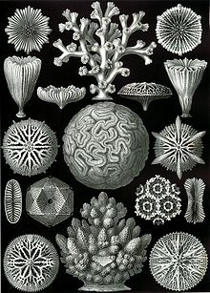
- They are considered the reef builders of the ecosystem
- The calcium carbonate skeleton they secrete distinguishes them from soft coral
Fire Corals
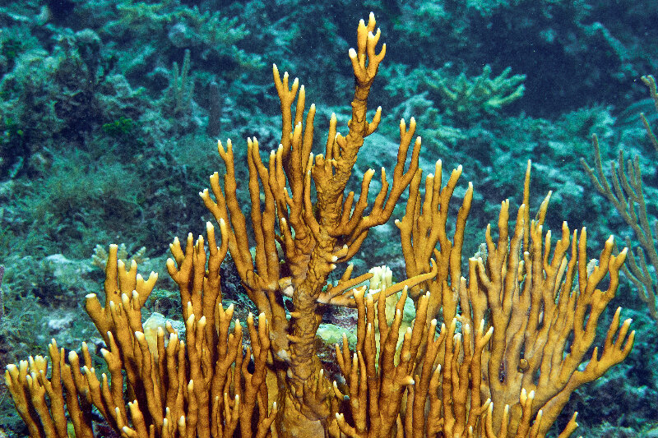

Lace Corals (Bryozoa)
- Lace corals scientific name is: Bryozoa from the Latin meaning moss animals
- delicate individuals that form colonies in thick, moss-like crusts.

SOFT CORALS: family Nephtheidae
Sea pens: (Pennatulacea)
- a type of octocoral (soft coral) related to jellyfish and anemones.
- their cousins are the reef-building hard corals.
- glow in the dark, can live to be 100 years old, and live in the soft ocean sediments of Puget Sound (Pacific NW)
Black Corals: (Antipatharians)
- black corals, also called thorn corals
- an order of soft deep-water corals.
- Are recognized by their jet-black or dark brown chitin skeletons, surrounded by the polyps (part of coral that is alive)
Alcyonacea
- called "soft" corals because unlike the stony corals, they do not have a rigid calcium carbonate skeleton.
- composed mostly of living tissue, though they do have tiny calcareous components called sclerites.
- sclerites are spiny skeletal elements embedded within the tissue.

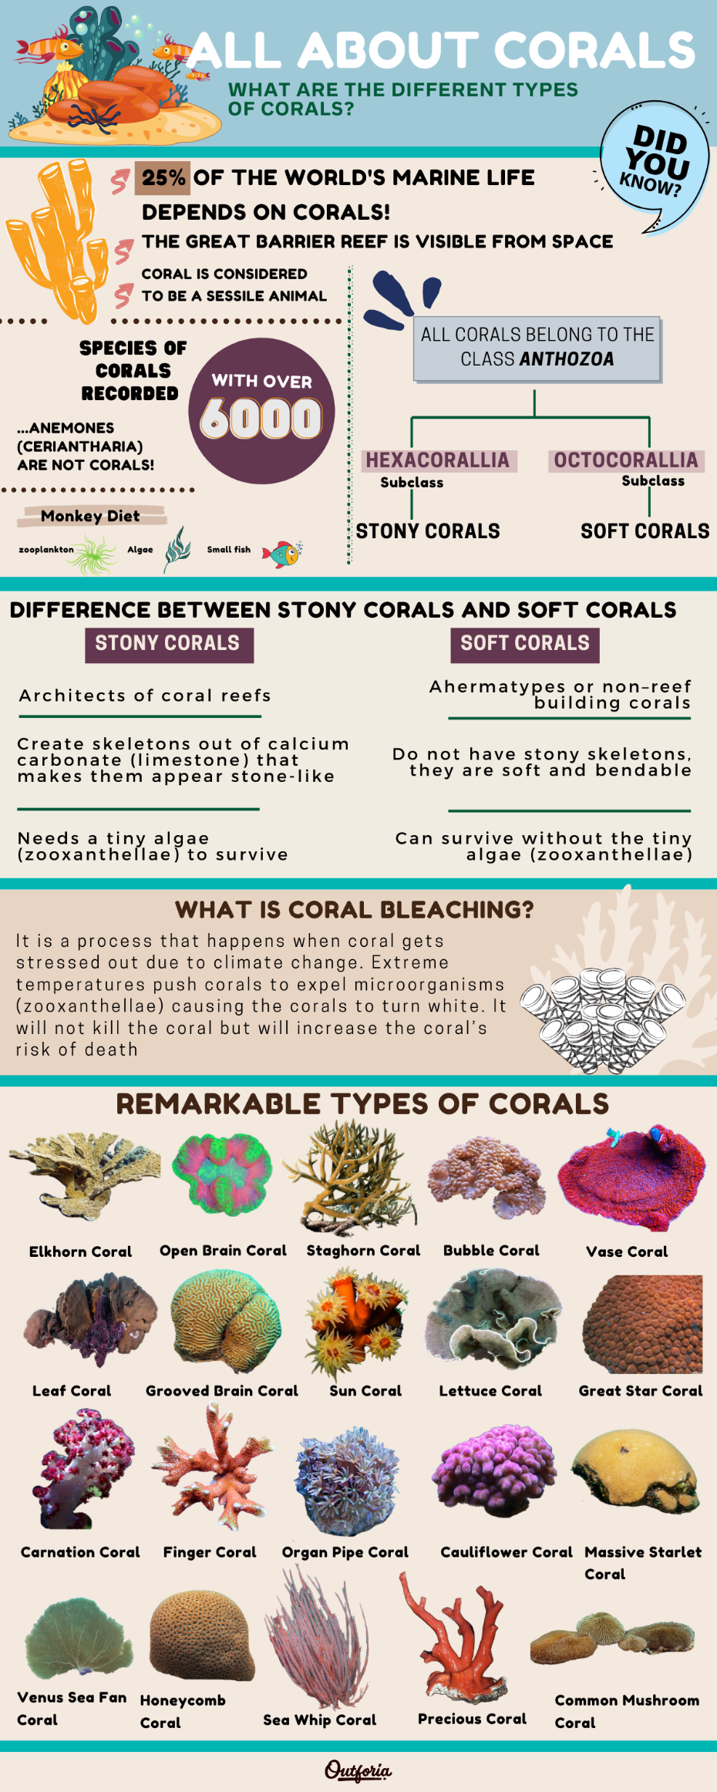
PART 3: Coral Research
Choose 1 type of coral to research (from the Coldwater or Tropical coral list below)
- Indicate if it’s a COLDWATER or TROPICAL CORAL (or found in both environments)
- Find out the Latin name, description (including different colors), where found globally +Fun Facts
- Explain 2 environmental issues: (e.g. at risk species? Effected by sunscreen? Reef destruction?)
- Find 2 photos (best examples)
- Organize your research on your e-Notes chart (from Ms. North)
  - COLD /DEEP WATER corals

Hard / Stony Corals (Hexacorallia)
- Bamboo corals
- Lace corals
- Solitary Cup corals – 11 species
- Coral spider hazard - lophelia pertusa
- Dendrophyllia

Soft Corals (Octocorallia)
- Black corals -15 species
- Bubblegum coral
- Coiled wire coral
- Leather corals – 9 species
- Organ pipe coral
- Red Trees
- Sea corn
- Sea pens and sea whips – 28 species
- Sea fans (Gorgonian corals) 44 species
Note: the corals listed below may not be cold water corals (you need to find out)
- Red or Pink corals
- Candelabrum gorgonian
- Purple Ribbon gorgonian
- Red Finger gorgonian
- Yellow Finger gorgonian
- Spiny gorgonian
- Slit-pore sea rod (tropical)

  - TROPICAL (warm water) corals
- Bubble Coral
- Cabbage Corals
- Carnation Coral
- Elkhorn Coral
- Finger Coral
- Fire Coral:(13 species) net coral, sea ginger, box coral, blade coral…
- Great Star Coral
- Green Star Polyps
- Sea fans (Gorgonian corals) 44 species
- Grooved Brain Coral
- Honeycomb Coral
- Kenya Tree Corals: cauliflower corals
- Leaf Coral
- Lettuce Coral
- Massive Starlet Coral
- Mushroom Corals (21 types) bubble, red mushroom, umbrella, metallic blue, purple hairy…
- Open Brain Coral
- Organ Pipe Coral
- Precious Coral
- Sea Pansies (bioluminescence)
- Sea Whip Coral
- Staghorn Coral
- Sun Corals
- Toadstool Corals
- Vase Coral
- Venus Sea Fan Coral

Website with a database of different coral types:
https://animal-world.com/Aquarium-Coral-Reefs

PART 3 – Fun Facts quiz
Test your coral and sponge knowledge after you’ve finished your coral research.
https://www.dfo-mpo.gc.ca/oceans/ceccsr-cerceef/quiz/index-eng.html

PART 4 –
Complete your e-notes research chart. (Graphic organizer from Ms. North)
Now you are ready to start creating your clay sculpture.

Ms. North’s research on Hard vs. Soft Corals
(research enabling me to create the list of Cold Water vs. Tropical corals)
The coral database for the Newfoundland-Labrador Shelves Bioregion contains 38 coral taxa:
- 61% are soft corals - family Nephtheidae
- 18% are sea pens
- 9% are large gorgonians (species of Paragorgia, Primnoa, Keratoisis + others)
- 7.4% were small gorgonians (species of Acanella and Anthothela);
- 0.01% were black corals (antipatharians)
- 0.04% were small cup corals (solitary scleractinians)
BRITISH COLUMBIAN CORALS (2009) Jamieson, Glen. Fisheries and Oceans Canada, Pacific Biological Station, Nanaimo, BC https://ibis.geog.ubc.ca/biodiversity/efauna/BritishColumbianCorals.html - BC corals
- cold-water corals, mostly gorgonians and hydrocorals, in the eastern North Pacific are most abundant a narrower depth zone.
- We use the term ‘coral’ for members of the class Anthozoa
- subclasses Octocorallia (soft corals, black corals and sea fans)
- Hexacorallia (stony and cup corals)
- class Hydrozoa, order Filifera (fire and lace corals).
- Although we include the octocoral orders Alcyonacea, Antipatharia and Penntulacea as corals, only the hexacoral order Scleractinia is included,

References:
Bulk Reef Supply. (2021) What is the difference between stony corals versus soft corals? https://www.youtube.com/watch?v=EXO8HJ-5gic&ab_channel=BulkReefSupply-SaltwaterAquariums

Canadian Science Advisory Secretariat (2010) Distribution of cold-water coral, sponges and sponge reefs in British Columbia with options for identifying significant encounters. (2010) CSAS ResDocs - 2010/090

Cruickshank, Ainslie (2/6/ 2023) ‘A century in the making’: Canada adds federal protection to Indigenous-declared marine refuge https://thenarwhal.ca/bc-marine-refuge-rare-corals/

Department of Fisheries and Oceans (12/2018) Cold Water Corals and Sponges
https://www.dfo-mpo.gc.ca/oceans/publications/soto-rceo/2012/page07-eng.html#a7

Department of Fisheries and Oceans (10/2019) Cold water corals and sponge reefs https://www.dfo-mpo.gc.ca/oceans/ceccsr-cerceef/index-eng.html

Department of Fisheries and Oceans. Test your coral and sponge knowledge with our quiz! https://www.dfo-mpo.gc.ca/oceans/ceccsr-cerceef/quiz/index-eng.html

Discovering Canada’s coral reefs (9/7/2022) https://www.statcan.gc.ca/o1/en/plus/1732-discovering-canadas-coral-reefs

Jamieson, Glen. (2009) BRITISH COLUMBIAN CORALS. Fisheries and Oceans Canada, Pacific Biological Station, Nanaimo, BC. Thesis. https://ibis.geog.ubc.ca/biodiversity/efauna/BritishColumbianCorals.html

Jamieson, Glen. (no date) Deep-water biogenic habitat in Pacific Canada: challenges to its conservation. Fisheries and Oceans Canada, Pacific Biological Station, Nanaimo, BC. https://pices.int/publications/presentations/PICES_16/Ann16_S7/S7_Jamieson.pdf

Oasis of the Deep: Cold Water Corals of Canada (12/21/2016) Webpage. http://science.gc.ca/site/science/en/educational-resources/marine-and-freshwater-sciences/oasis-deep

Pilson, Gaby. (1/21/2023) How corals are classified. Outforia. Infographic.
https://outforia.com/types-of-coral/#classification

Pilson, Gaby. (1/21/2023) Types of Coral. Outforia. Webpage. https://outforia.com/types-of-coral/

Roberts, J. Murray (Feb 2021) Are cold-water coral reefs canaries in the coal mine of climate change, and what can we do about? Atlantic / OneOcean Webinar. https://www.iatlantic.eu/wp-content/uploads/2021/02/Roberts_CWC_Climate_Change.pdf

Shannon, Cynthia Ann. (10/1/2018) Coral Reefs: Rainforests of the Sea. https://www.dfo-mpo.gc.ca/science/organization/sec-ces/atlantic-atlantique/blog/2018-10-01/index-eng.html

